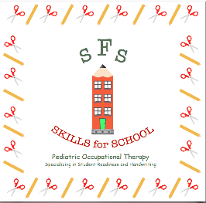
Skills for School Policies and Procedures

Payment Policy:
Skills for School LLC is private pay. Payment for each session is due in full the day of the appointment. We accept cash, personal checks and credit MC/VISA/DISCOVER. We are also Gardiner Scholarship Providers.
Attendance Policy - Frequent Cancellations and No-Shows:
Skills for School LLC wants for each student to be successful. To do that, we try to create unique and specific plans for each of our students. Preparation time is used to select and gather materials for individualized sessions. When a student does not show for an appointment or give sufficient notice to cancel an appointment, we have lost time and efforts on your behalf. To avoid a fee, all notice of cancellations must be given within 24 hours prior to the appointment time. An appointment that is missed without notification will be charged a $25 no show fee.
COVID-19:
We here at Skills for School LLC are very aware of the public health concerns related to Covid-19. We are practicing current CDC recommendations to keep everyone safe. Due to this we are only providing 1:1 sessions and practicing social distancing in both the waiting room and the treatment space.
- At this time, we will be staggering our schedules to allow only 1 family at a time in our waiting rooms.
- All toys and shared materials have temporarily been removed from our waiting area.
- We are scheduling 15 minutes between students to clean all common surfaces including toys, tables, furniture, door knobs and other therapy materials before and after each session.
- We will wear shields or masks as much as able and appropriate during and after sessions. As therapists, there may be times during the session when we need to utilize therapeutic techniques that will require our face and mouth to be visible to the student. Therefore, there may be times that it will be necessary to conduct sessions without the use of a mask, however, we will do our best to conduct as much of the session as possible with a face covering.
- Each student will have their own individual high touch items, including pencils/crayons, in a labeled bag.
- Hand sanitizer will be available to all students before, during and after their session.
- Students will be asked to wash hands or use hand sanitizer prior to the start of a session
- Students are welcome to wear their own mask provided by parents during sessions if desired.

By signing below, you acknowledge receipt of the policies as listed above. You further acknowledge that you have read, understand, and accept each policy in its entirety.

_______________________________________________/________/_________ Signature Date
Parent Guardian Signature
_______________________________________
Student Name

